Practical Gaming 2024

Name of Student - Robert Smyth

T Number - T00145976

Name of Project - Bull Dungeon

Gameplay
The game starts in the Main Menu. The player clicks the play button to start the level “Level 1”. When the level loads the player controls a character called Mushroom Man. Movement is via the WASD keys, with Spacebar to jump, Shift Key to Sprint, Q and E Keys to strafe left and right, F Key to shoot arrows (if arrows are in the inventory), P Key to pause the game and Escape Key to enter an options menu. The C Key allows the player to look behind them, clicking the left mouse button allows a camera zoom where the mouse is pointing.
There is a health bar visible on screen that keeps track fo the players health. There is also an arrow counter beside this health bar which displays the number fo arrows the player has in their inventory.
The player collects chests around the level, each providing different arrow amounts to the player.
The goal is to move towards the boss at the end of the level, who chases and attacks the player if within a certain range. If the player is hit by the boss, damage is taken and the health bar depletes. If the health bar reaches 0, the player dies and a death scene is loaded with the option to try again.
If the player shoots the boss with enough arrows, it will trigger different attack phases, each causing more damage than the other. If and when the player kills the boss, a portal is activated behind the boss and when entered by the player, ends the game.

Coding
Under each of the following headings, please describe the concept, why is it or isn’t it useful/needed, where do you implement in your project, you may provide screenshots or cut and past code segments etc..

- Frame Rate Independence
  - Frame rate independence makes sure the games logic behaves consistently, irregardless of the players hardware.
  - It can be seen being used in the characters movement script, charMovementScript.cs via the Time.deltaTime. This ensure the movement is consistent.
  - Without this, the movement speed would be faster on higher FPS capable systems and slower on lower end devices. This will cause unfair gameplay.
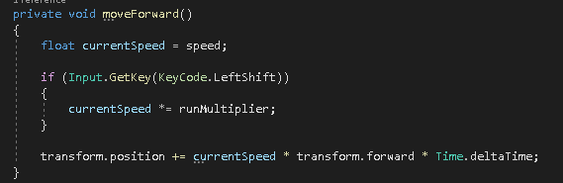
- Interfaces
  - Interfaces are used to show what methods a class or classes must implement without defining how they are implemented.
  - In the interface iHealth, this is used to ensure both the character(player) and the boss implement the takeDamage() method.
  - This allows different objects to take damage in their own way while ensuring their interactions are correct and consistent.
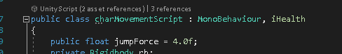
- Inheritance
  - Inheritance allows a class to use code from a super class, or parent class allowing code reuse.
  - Inheritance in my game, would include my characters movement script inheriting from the MonoBehaviour class.
  - I could have used it to allow the health of the player and the boss to be the same logic in regards to depletion or regeneration.

- Case pattern
  - A case pattern, although not implemented, would have allowed switch statements to handle many different outcomes.
  - For example, in the BossBehaviour script, I could have used switch statements to handle the different boss states i.e. Idle, attack_01, attack_02, attack_03, die etc.
  - This could have made my code cleaner when checking and using the different conditions.
  - For example, here I could have used:
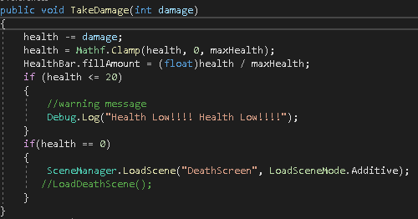
***
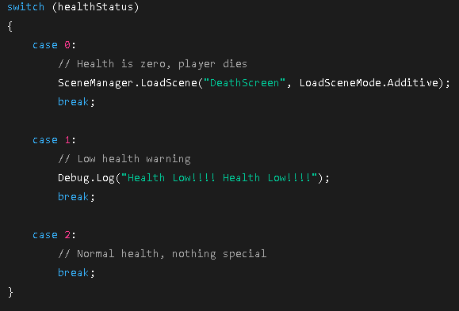

- Observer Pattern
  - This is where one object tells another when a change occurs.
  - My script ArrowDisplay recognises when my Inventory changes and tells my UI to display different figures.
  - Code: arrowText.text = "x" + Inventory.GetArrowCount().ToString();
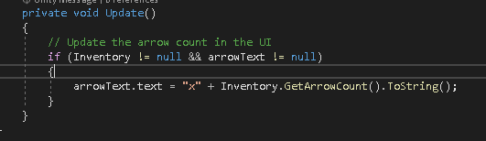
- Polymorphism
  - This allows methods to behave differently depending on the object in the game that calls them
  - I implement polymorphism via the iHealth interface, where different classes use the TakeDamage() method.
  - This is useful as it encourages flexible code and scalable code.
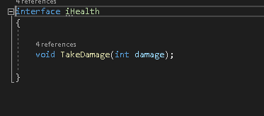

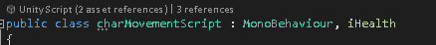

- Communication between scripts/game objects
  - This is where scripts interact with other scripts.
  - I use this in charMovementScript where it access the Inventory script to shoot arrows, the ArrowDisplay scripts gets different values from the Inventory script and the ArrowPickup scripts checks for a collision between the player and the chests that give arrows.
  - An example would also be where the ChestPickup scripts accesses the players inventory to add these arrows.
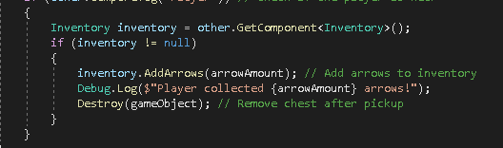
- Instantiation and Prefabs
  - These are reusable object, and the running of the game instantiates these objects.
  - It allows for object creation e.g. the arrows when pressing F to shoot.
- Magic Numbers
  - These are values already coded in the scripts.
  - For example where I change gameplay by suggestion if a players health is below 50 to do an action. if (currentHealth <= 50) Also where I initialise a serialized field to display the health warning if the player reaches a certain health threshold, [SerializeField] private float healthWarningThreshold = 50f;. This is important as it make it easier to read the code and maintain the code.
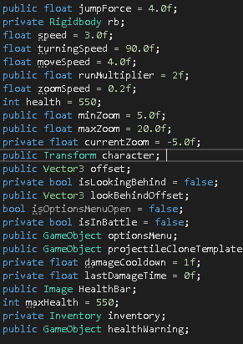
- Model Animation
  - This is where Unitys animator displays certain animations. My boss has 3 different attack animations, a death animation and a walk animation. Each of these are controlled by unities animator.
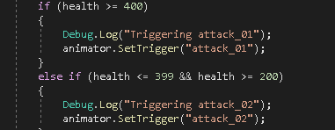

- Self made models and or animations
  - I do not have any self made models or animations. The ones used in my game came with the prefabs of the models used in the game.

- Interactions between objects/scripts
  - This is where one script affects another.
  - For example the ArrowPickup affects the inventory scripts and the boss tracking the player is don’t by the GameObject.FindWithTag(“Player”)
  - This is useful for the games actions such as pickups, UI and the combat between the player and the boss.
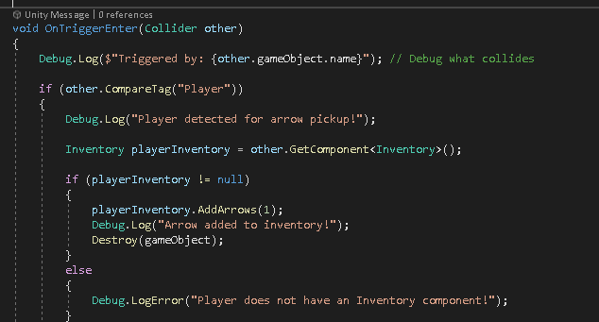

- Propper code placement
  - This is where code is organised in classes and methods like Start(), Update() and OnTriggerEnter()
  - The OnTriggerEnter is used for picking up the arrows from the chests the be added to the inventory.
  - The Update() is for code that needs to run in every frame of the game e.g. checking player input and/or updating the UI.
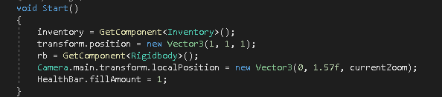
- Code repetition
  - This is where the same logic is repeated, leading to slower runtime and more memory usage.
  - It would be useful to not use the same code in multiple places, but instead putting it into a method and calling that method.
  - This would make code easier to read and maintain.

- Feature 1
  - The Health System
  - The player and boss have different health values that decrease when taking damage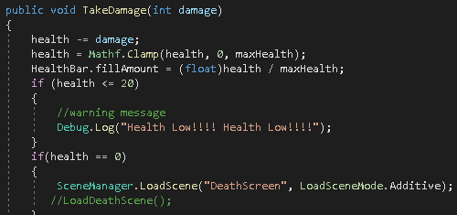

- Feature 2
  - The inventory system
  - This is used to track arrows, especially when being picked up or being used when pressing F to shoot.
  - This adds resource mechanic to the game.
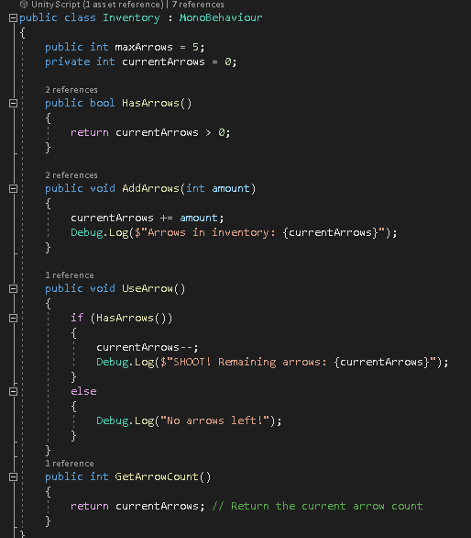

- Feature 3
  - Scene Management
  - The main menu leads to the game and the gameplay, which can lead to the death of the character returning them to the main menu, and/or the player kills the boss enabling the end portal which when entered loads the final scene that leds the player upon a button click back to the main menu again.
  - This ensure a full loop is initiated within the game itself.
